The Journey to Wellness: Mental Health during a Pandemic

Host Voiceover:
The looming threats of severe shortage, a pandemic, financial losses, political and racial unrest have been some of the major factors that have contributed to stress this past year. There is another health issue that has to continuously be considered, a lack of community is some of the major stressors that presumably have contributed to emotional distress and the mental illness during the pandemic. Stay at home and confinement directives are new to the American way of living which has forced many families into emotional distress.

In our episode today, we will be speaking with (Guest) on how we can grow and protect our mental health. We’ll discuss certain social determinants of health that have historically prevented certain groups from having a fair opportunity for mental and emotional health. Also, we’ll share helpful self-care tips.

GUEST BIO:
Dr. Latise Hairston is the Founder and Chief Impact Officer of HOPE Consulting and an adjunct faculty at Medaille College and Fielding University.
Latise began her career in child welfare as a social worker and counselor, where she was an activist for social justice. Latise is a dynamic, accomplished certified Diversity, Equity & Inclusion Strategist respected for delivering a consistent creative vision based on data-driven decision making.

Interview:

- Topic: Parenting and Schooling
- I think it’s interesting that on the morning news when journalists are speaking about parenting there are images of parents working from home or letting their kids out in their beautiful backyard for a break. That’s a stark difference of how many families live in lower income communities. School is known as a place of escape and a key to a world of possibilities. These changes have lead to behavioral changes and regression. How should parents navigate these trying times and offer their children similar opportunities?
The pandemic has exacerbated well-documented opportunity gaps that put low-income students at a disadvantage relative to their better-off peers. Opportunity gaps are gaps in access to the conditions and resources that enhance learning and development, and include access to food and nutrition, housing, health insurance and care, and financial relief measures.
One of the most critical opportunity gaps is the uneven access to the devices and internet access critical to learning online. This digital divide has made it virtually impossible for some students to learn during the pandemic.

parents are turning to family members, neighbors and friends for child care and help navigating distance learning.
As part of these informal networks, parents are using text messages and online workshops to reach other parents, or even a knock on a door to wake a child up for school.

Steps to Help Provide Stability and Support to Children
- Maintain a normal routine
- Talk, listen, and encourage expression
- Give honest and accurate information
- Teach simple steps to stay healthy
- Be alert for any change in behavior.
- Reassure children about their safety and well-being

- Topic: Coping Professionally
- In light of school closings, restaurant, business closures and the economic collapse due to the pandemic, many professionals are struggling and as a result that trickles into the work place. Professionally how can we manage toxic stress on the job? Is it ever a viable option to leave a toxic job during a pandemic?
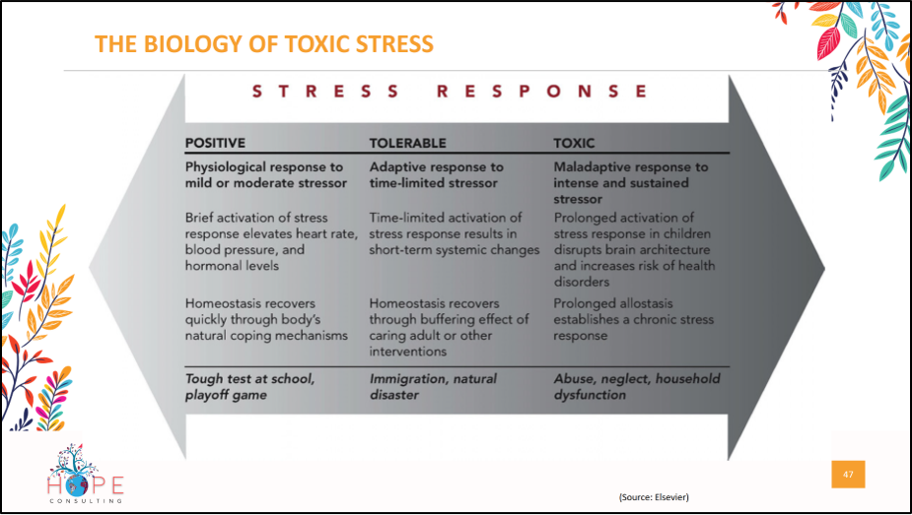
A toxic environment keeps people in a fight or flight mindset—the constant pump of cortisol, testosterone, and norepinephrine generates physical, emotional, and mental stress,
- CDHS- Meg; accountability

- Topic: BIPOC and OUR STRUGGLES RELATED TO MENTAL HEALTH
- Debunking cultural stigmas associated with psychiatric illnesses. Coming from a Afro-Caribbean background, it’s usually frowned upon or offensive to tell someone struggling with mental health to see a “head doctor or therapist”. How do we begin to address how that idea has eliminated us from the help we need? Do you have any resources to share?
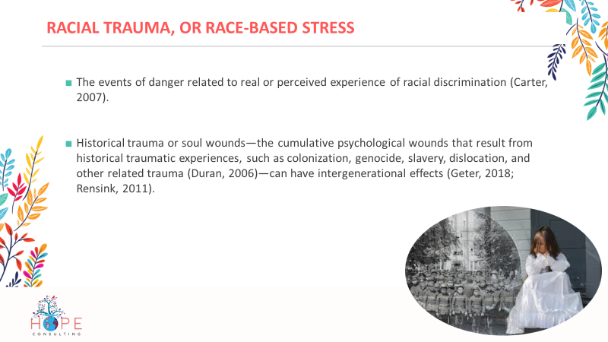
- Iatrophobia= healer- fear of healer
- Race based trauma Hypervigilance to threat
- Flashbacks
- Nightmares
- Avoidance
- Suspiciousness
- Overeating, undereating
- Somatic expressions: e.g. headaches & heart palpitations
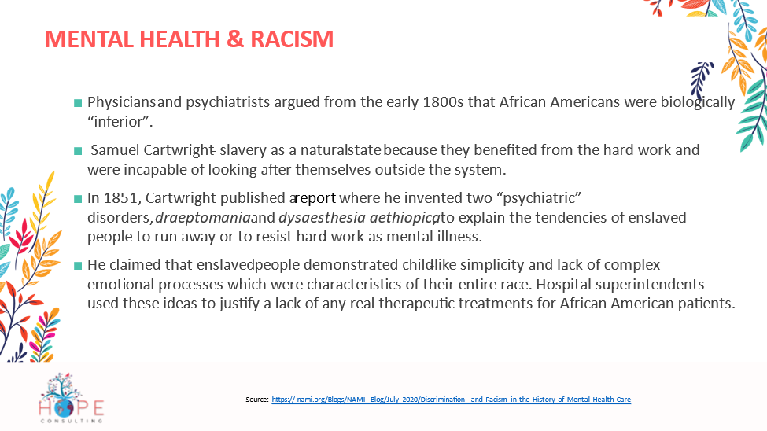
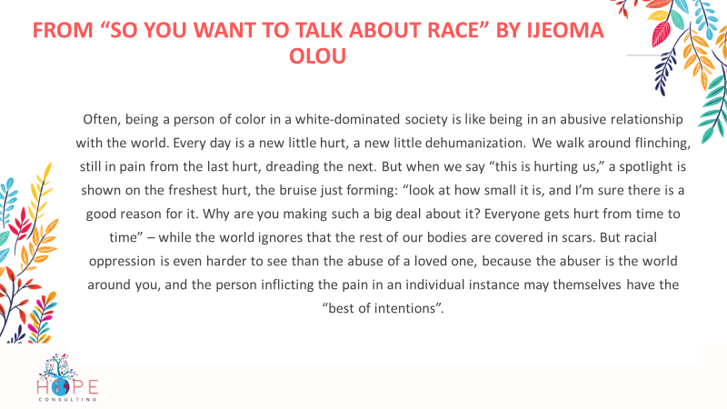
Cara Page and Kindred Southern Healing Justice Collective cleared a path and told us that “healing justice...identifies how we can holistically respond to and intervene on generational trauma and violence, and to bring collective practices that can impact and transform the consequences of oppression on our bodies, hearts and minds.”

- TOPIC: HARNESSING THE POWER OF COMMUNITY
- How can we as a community approach such a delicate topic in an informative way with loved one?
We have been taught and conditioned to turn to the state in moments of crisis and trauma, to turn out and away from the communities and relationships that hold us. In this moment of community grief, let us find each other, and radically turn in to each other with love, consensually present each other with our hurts and needs, and strategize as community to get those needs and desires met. We must remember, share, and practice strategies for grounding, support, resilience, transformation, and accountability.
We must support each other’s wellness. One way to do this is to create a wellness plan for yourself, and encourage folks in your community to create a wellness plan for themselves. Strategize with your community about your wellness plan and meeting your needs.
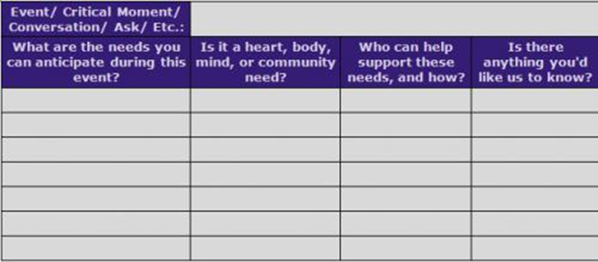
- What are some red flags and warning signs we should be aware of?
the importance of distinguishing warning signs from risk factors, the group
defines warning signs as the earliest detectable signs that indicate
heightened risk for suicide in the near-term (i.e., within minutes, hours, or
days), as opposed to risk factors which suggest longer-term risk (i.e., a year
to lifetime).
Call 911 or seek immediate help from an emergency mental health
provider such as Crisis Services (716-834-3131, 24 hours a day, 7 days
a week) when you hear or see any one of these behaviors:
✓ Someone imminently threatening to hurt or kill themselves
✓ Someone currently looking for ways to kill themselves, e.g., seeking
access to pills, weapons, or other means
Seek help by contacting Crisis Services at 716-834-3131 or The
National Suicide Prevention Lifeline at 1-800-273-TALK for a referral
should you witness, hear, or see anyone exhibiting any one or more of
these behaviors:
✓ Hopelessness
✓ Rage, anger, seeking revenge
✓ Acting reckless or engaging in risky activities, seemingly without
thinking
✓ Feeling trapped—like there's no way out
✓ Increasing alcohol or drug use
✓ Withdrawing from friends, family or society
✓ Someone talking or writing about death, dying, or suicide
✓ Anxiety, agitation, unable to sleep, or sleeping all the time
✓ Dramatic mood changes
✓ No reason for living; no sense of purpose in life
Please be aware that, aside from direct statements or behaviors threatening suicide,

Depression is a common but serious mental illness typically marked by sad
or anxious feelings. Most people occasionally feel sad or anxious, but these
emotions usually pass quickly—within a couple of days. Untreated
depression lasts for a long time, interferes with day-to-day activities, and is
much more than just being "a little down" or "feeling blue."
The symptoms of depression vary. If you are depressed, you may feel:
❖ Sad  Anxious
❖ Empty  Hopeless
❖ Guilty  Worthless
❖ Helpless  Irritable
❖ Restless
You may also experience one or more of the following:
❖ Loss of interest in activities you used to enjoy
❖ Lack of energy
❖ Problems concentrating, remembering information, or making
decisions
❖ Problems falling to sleep, problems staying asleep, or sleeping too
much
❖ Loss of appetite or eating too much
❖ Thoughts of suicide or suicide attempts
❖ Aches, pains, headaches, cramps, or digestive problems that do not go
away

- Self-care has been a major form of dealing with mental stress. It can come across as so broad where some people don’t know where to start and now that we are following self-care directives, how can we be creative with our self-care routine?

“Rest is not the same thing as sleep. Rest encompasses the restorative activities we do that help us refill our tanks, which become depleted throughout the day,” says Dr. Dalton-Smith. “It truly reenergizes us.”

In her research, she has found that most people have a rest deficit. “We live in a society that doesn’t know how to not be busy,” she says. “We’re always working and using energy, so we’re getting depleted.” COVID-19 has, of course, made matters even worse. (Hello, quarantine fatigue.)
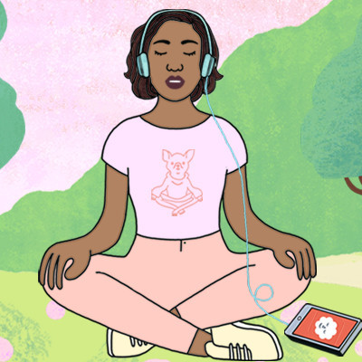
“We're under a lot of stress from all the uncertainty," says Dr. Dalton-Smith. “We don’t know what’s going to happen six months from now with the virus or with our jobs. There’s a lot of anxiety that goes along with that. That’s why it’s especially important to learn how to get the right type and amount of rest.”
Yes, there are different types of rest, too. Here's how to start.

Figure Out Your Specific Rest Needs
In her work, Dr. Dalton-Smith has identified seven types of rest everyone requires. “One size does not fit all when it comes to rest,” she says. “Everything you do draws from a different pool of energy. The best rest occurs when you revive the specific kinds of energy you regularly deplete.” These are the seven types of rest:
- Creative: The type that inspires and motivates you.
- Mental: When you quiet your mind and focus on what’s really important.
- Physical: The rest that relieves your body of muscle aches and tension and helps improve your sleep.
- Social: You spend time on relationships you cherish and with people who enhance your life.
- Emotional: The ability to express your deepest feelings and be your genuine self.
- Sensory: Gives you a respite from background noise, including negative self-talk and digital devices.
- Spiritual: You feel that you are part of something bigger, as well as a sense of belonging and fitting in.

If we want to democratize wellness, we have to dismantle the obstacles that inhibit many of us from caring for ourselves and others, and reckon with systems that tout well-being as a luxury good instead of what it is: a fundamental birthright. What would it look like to shift our perception of wellness to include the collective?
“Healing justice” is both a term and movement, first coined by the Atlanta-based Kindred Southern Healing Justice Collective in 2007, that aims to address widespread generational trauma from systemic violence and oppression by reviving ancestral healing practices and building new, more inclusive ones.

the healing justice movement, reimagining wellness for the collective, and why we need more walks with friends—not more bath time—in the name of self-care.

Taking a bubble bath isn’t necessarily healing justice, right? Healing justice is really about looking at the systems, legacy, intergenerational trauma—all these pieces where harm still lingers, and beginning to restore and heal that harm.

Guest Checklist:

-Click the Anchor browser link or Download the Anchor App.
-Send brief bio
-Send headshot
-Headphones are required
-The edited show will be sent to the guest prior to launch
-Truly Rachel shop Gift Kit will be sent as a Thank You.

